**Modifying XPlatformCloudKit Applications to Work with YouTube Data API v3**

All Windows 8 and Windows 8.1 XPlatformCloudKit apps that include YouTube videos must be modified to use the current Data API supported by Google. To do so, you will need to perform the following steps:

**Before you start** You need a [Google Account](https://www.google.com/accounts/NewAccount) to access the Google Developers Console, request an API key, and register your application.

**For each of your applications you will need to go through this process.**

Login to the [Google Developers Console](https://console.developers.google.com) and create a project by clicking Create Project.

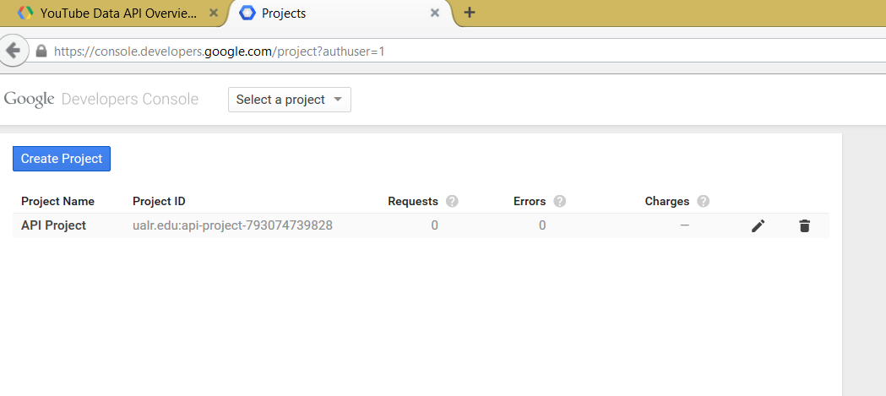

Enter the name of your application, check the Terms of Service box, and click Create.

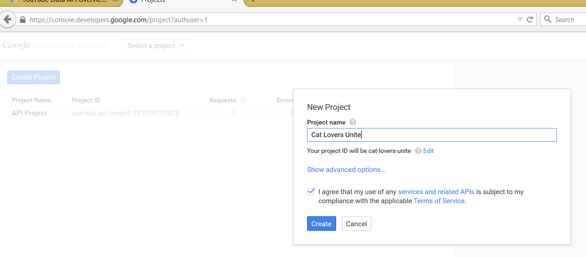

When you get the following screen, select APIs & auth

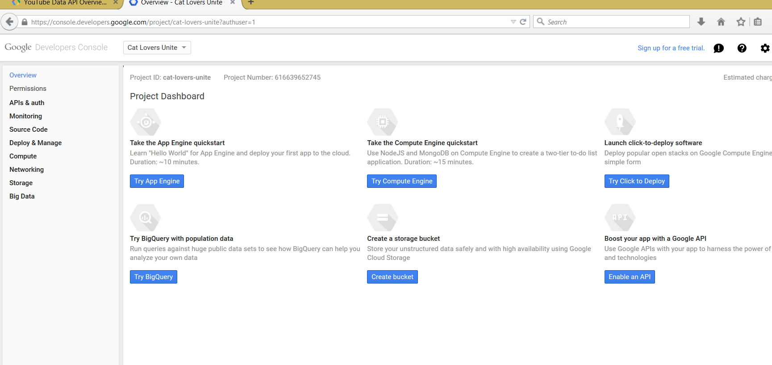

Then select Credentials.

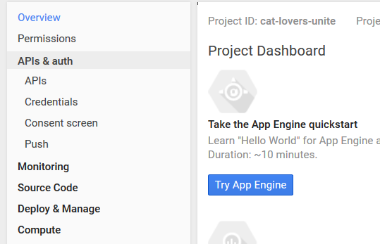

Click on Create new Key

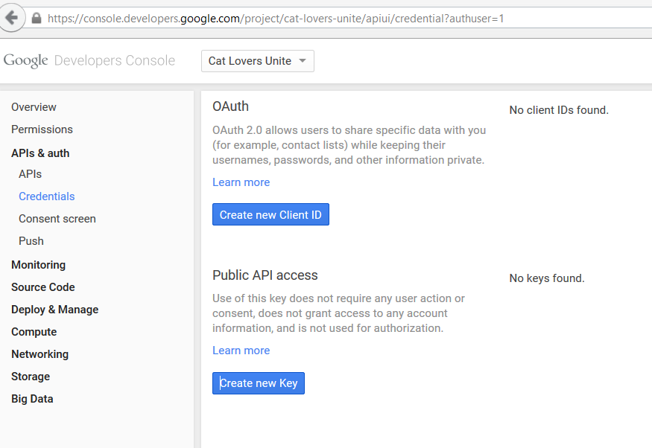

Select Browser Key

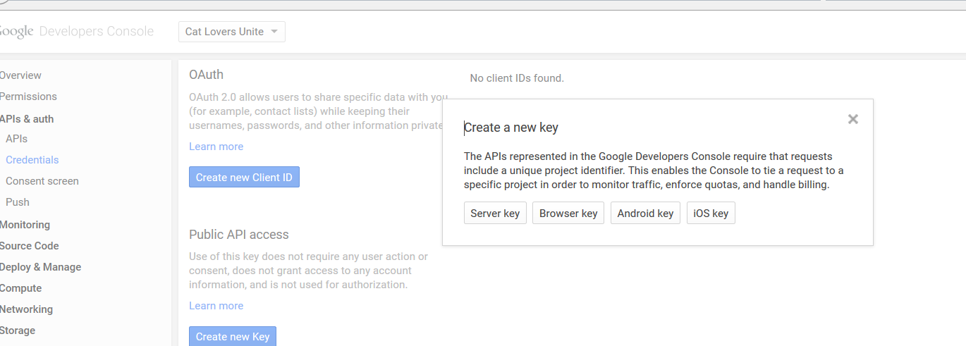

Click Create

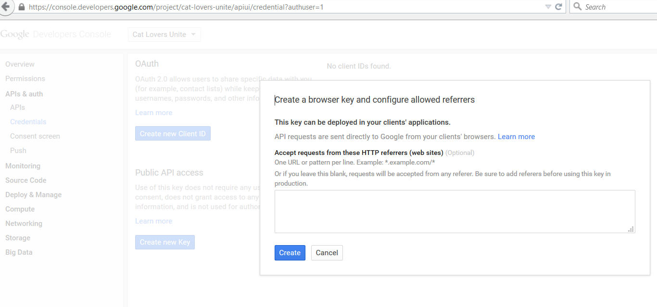

Copy the API Key the system returns. Do not use the one in this documentation as each key is limited to 50,000 hits per day.

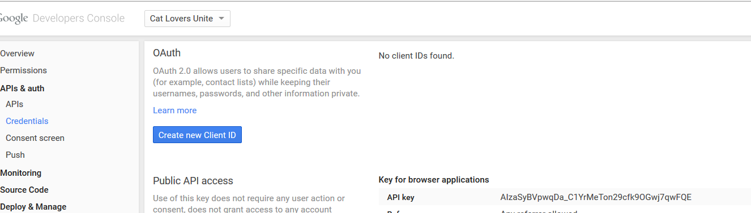

Open your application in Visual Studio. Go to XPlatformCloudKit.PCL. Insert the API Key in between the “” marks on the line in AppSetting.cs



Comment out any lines in your existing code under *URLs to RSS Data Services* that refer to YouTube Playlists. Instead of inserting the code there, you will not insert the reference to the playlist under *Youtube Service*. Insert the reference between the = and the &. You will no longer need to have multiple references for playlists with more than 50 videos. This one line of code will return all the videos in the playlist.



If you are modifying an existing XPlatformCloudKit application, you will also need to modify line 76 in YoutubeServices.cs to read:

if(description != "This video is private." && description != "This video is unavailable.")

This line of code does not need to be changed if you are downloading a new copy of the XPlatformCloudKit master file.

=============